CPSC 1050 - Chapter 5 & 6 Lab

**Lab Questions (10 Points)**

1. The basic operation cycle of a computer is known as the Fetch-Execute Cycle or Fetch-Decode-Execute Cycle. Complete the following table: (2 Points)

|  |  |  |
| --- | --- | --- |
| Cycle | Which Unit(s) of von Neumann Architecture are involved  (Memory, CPU, ALU, Control, Input, Output) | Computing Components Involved (Memory, CPU, Input Devices,  Output Devices) |
| Fetch | **Control Unit, Memory Unit, ALU** | **CPU, Memory** |
| Decode | **Control Unit** | **CPU, Memory** |
| Get Data | **ALU, Control Unit** | **CPU, Memory** |
| Execute | **ALU, Control Unit** | **CPU, Memory, Input Device, Output Device** |

1. What are the two key characteristics of the von Neumann Architecture? (2 Points)
2. **The units that process information are different from the ones that store information**
3. **Data and the instructions that manipulate the data are logically the same and could be stored in the same place**
4. Write the pseudocode to calculate the volume of a cylinder for radius = 10.50, height = 15.01, and pi = 3.1415. (2 Points)

(Assuming language is Python)

**Import math module in order to get the pi constant**

**Create the input variables for radius and height**

**Create a result variable that equals radius**2 * height * pi**

**Print result variable**

1. Download the pep8 program (Windows OS only) from BrightSpace. Enter the following machine language program into pep8 virtual machine’s Object Code window using hexadecimals – be sure to use zz instead of 00 as Stop. And set the output to be Terminal I/O. Insert a screenshot of a successful execution of the program as your answer to this question. (2 Points)

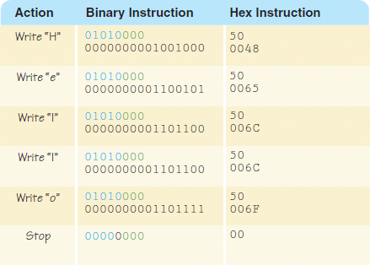

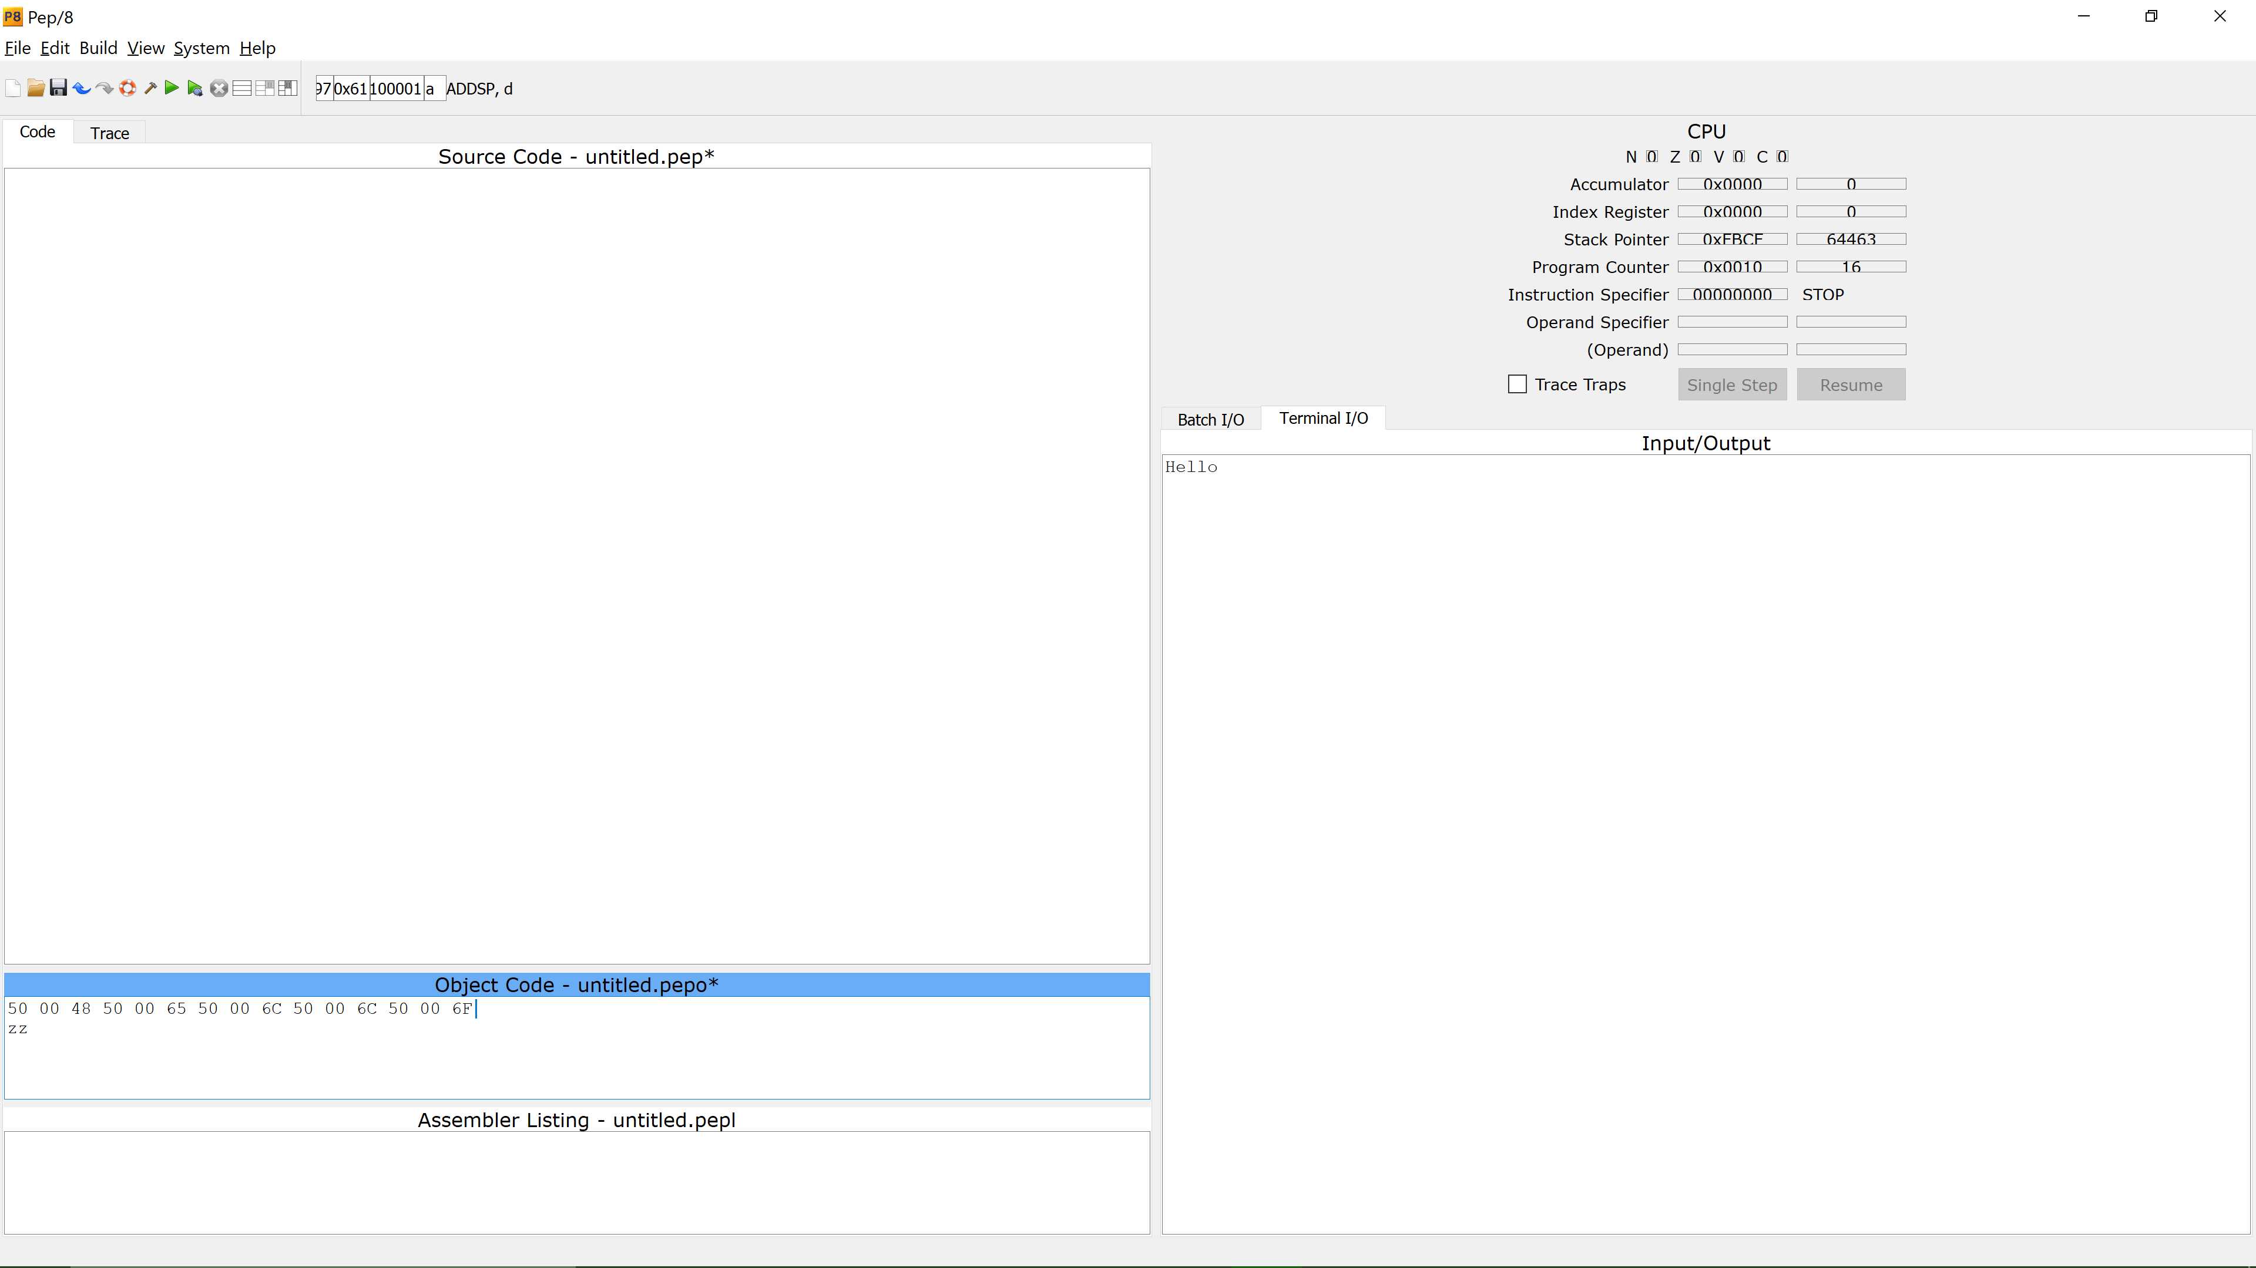

1. Download the pep8 program (Windows OS only) from Brightspace. Enter the following assembly language program into pep8 virtual machine’s Source Code window. Insert a screenshot of a successful execution of the program as your answer to this question. (2 Points)

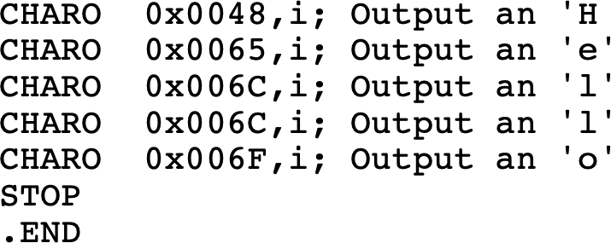

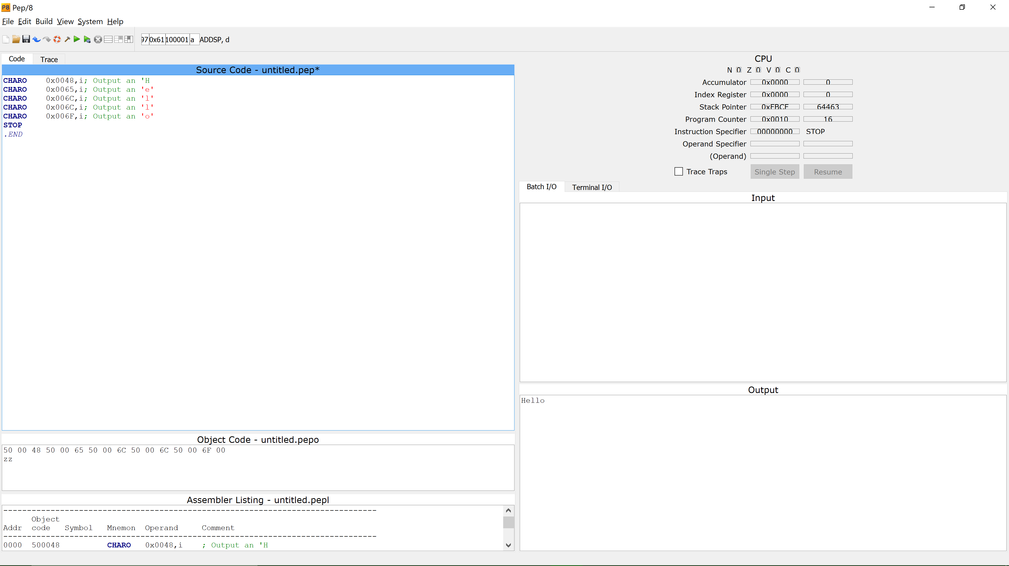

# SUBMISSION

One document with all answers to Brightspace in the folder called **Chapter 5 & 6 Lab**. The file format may be PDF, DOCx, or whatever file format based on the platform you choose to create your file.

# DUE DATE

**See BrightSpace. No late submissions accepted nor graded.**